Worksheet 1
Use cases
Exercise

1. Draw up a domain model for the problem statement:

There is a requirement for a software application to allow admin staff at
a college to enrol students on evening courses, such as Java programming, web development or C++ programming. Each course is identified by
course ID. Each course runs once a week. When students are enrolled, the college needs a record of their name, address and telephone number. Students can be enrolled on more than one course at a time.

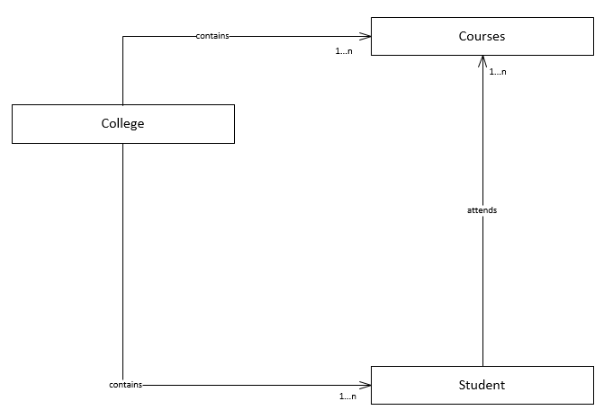
Enrolled on
Contains
1…n
Briefly explain your domain model in no more than a paragraph:
The college can contain a non-specific amount of students and courses which it interacts with. A student is not limited to the number of courses of which they are enrolled and therefore can have interaction with a non-limited amount of courses.

2. Draw up a use-case diagram showing the following use cases. Your use-case diagram should not show any use cases besides the following. There is no need to use <<invokes>> just yet.

* Enrol a student on a specific course in the college
* View the details of a given student
* Add a new course
* Book a room
* Unbook a room
* Change the personal details of a student
* Enrol a student in the college, as a whole
* Remove a student from a course
* Change course details (room, time)

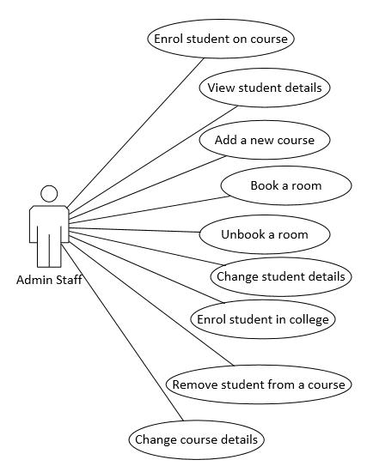

3. Draw up a use-case text for the following use case in the evening class example:

* "enrol a student on a specific course"
* "change personal details of a student"

Use the problem statement to help you.
Step | Actor Action | System Response
1 | The use case begins when the admin staff selects to enrol a student on a specific course. | -
2 | - | System prompts the user for the student details (name, address, telephone number, course ID)
3 | The user enters the details specified in step 2. | -
4 | - | System checks the validity of the details e.g. telephone number is sensible
5 | - | System checks that the member is not already enrolled (same student, same course ID).
6 | - | System allocates the student to the course.

Step | Actor Action | System Response
1 | The use case begins when the admin staff selects to change the personal details of a student. | -
2 | - | System prompts the user for student ID
3 | User enters desired student ID | -
4 | - | System checks that the student ID is a valid one.
5 | - | System displays the current student details to the user.
6 | User enters desired alterations. | -
7 | - | System checks that new changes are valid.
8 | - | System applies new changes.

Further questions

1. Re-draw your use case diagram to use <<invokes>> where appropriate.

